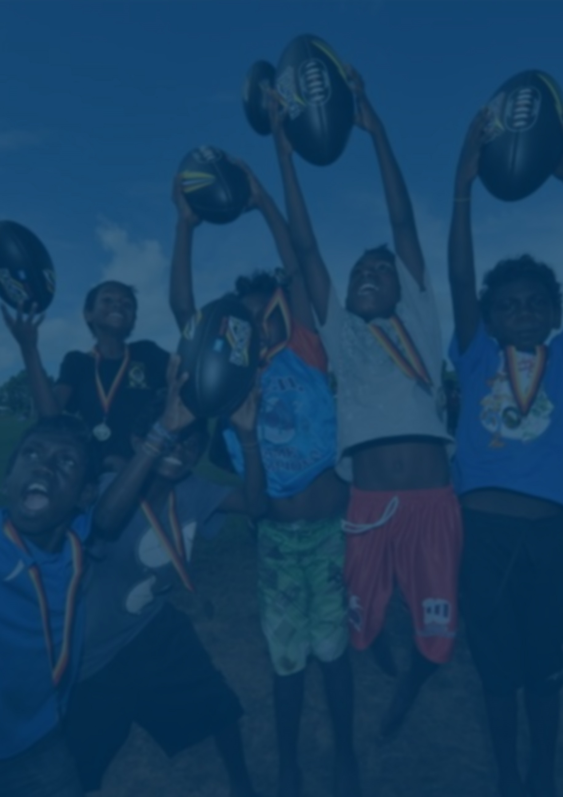

Indigenous Australians’ participation in sports and physical activities
Part 2, Qualitative research (ACT Report)
Prepared for:
Active Canberra and Australian Sports Commission
Prepared by:
Craig Young
Phone: +61 2 8912 5600
Email: Craig.Young@ORCInternational.com
ORC International Ref: AU3000360.rep
June 2017

Executive Summary

ORC was commissioned to conduct research on participation in sport and physical activity amongst Indigenous people in the ACT region (including Queanbeyan). The research explored current participation levels and behaviours, key drivers and barriers to participation and the role of sport and sporting clubs within communities. The research was qualitative, with focus groups and interviews being with Indigenous people age 15 years and over. Additionally, interviews were conducted with intermediaries who are engaged in the organisation development of sports and physical activity programs which target Indigenous participation. Respondents were recruited by local Indigenous organisations which ORC partnered with for the research.

Overview of sports and physical activity participation in the Indigenous community in the ACT
Amongst Indigenous residents of the ACT and Queanbeyan in general, participation in sports and physical activity tended to decline with age. Typically, children of school age participated in a wide range of sports. In later teenage years, while some continued to be involved in organised sports, others changed activities somewhat, with some starting to take up sports like boxing or non-sport physical activity like going to the gym. Organised sports participation tended to continue into early adulthood, but with increasing numbers of people dropping out as age progressed. For adults (both young and older) non-sport activities like ‘boot camp’ and going to the gym, or more passive activities (especially walking) were popular and this often continued into later life.
Children participated in a wide range of sports – particularly rugby league for boys and netball for girls, but with touch football (AusTag) and soccer both very popular for both sexes. In teenage years going to the gym and boxing also become popular. Overall, it was felt that schools, community groups and families have a key role to play in ensuing youth continue to be engaged and supported to participate in sport. Intervention by family, schools and sports clubs is key in ensuring children (and their parents) take steps to stay engaged in sports.

The decision-making process – participation drivers and barriers
The process of deciding what sports are engaged in obviously varies by age. For younger school age children, the primary drivers were parental choice (which obviously often takes children’s interest into account), but as children get older they have greater agency over their decisions, though the influence of parents and other extended family as role models remained strong.
Typically, up to the end of primary school children were strongly influenced by parents’ and siblings’ involvement in sport, the sports played by the extended family (cousins, uncles, aunts) and friends, as well as what is on offer in their community. Enjoying the game for the team and social aspects and for the love of the game itself were key motivators for children (especially) and adults. Competition, or to be the best was a motivating factor to some, but not most.

The engagement of the Indigenous community (the extended family and peer group network) was also a key factor in sporting and physical activity participation, with children and adults reporting being more likely to participate in organised sports or activities like going to the gym or boot camp, if they were accompanied by family members or close friends. The decline in sporting participation in early adulthood was often exacerbated by the demands of employment, family and also ‘temptations’ (socialising, going out etc). As such, programs that focus on community/family involvement, have an Indigenous specific focus (enabling Indigenous youth to feel more comfortable) and help build and support resilience are likely to be more successful. Such programs were seen as important in overcoming racism, or non-inclusive practices, which could also be a barrier to participation.

Cost was reported as a further barrier to participation – both for adults and their children. The main costs cited were seasonal costs including the cost of seasonal enrolment/registration in sport as well as buying sporting gear (especially football boots and uniforms). Relatively lower median incomes and a relatively high incidence of single parent families exacerbated these cost issues. Another key barrier was transport and logistics – both getting to weekly training as well as traveling for weekend matches. This particularly challenging for families with multiple children. The cost issue was exacerbated for parents with multiple children playing sport, making it difficult to ferry children to multiple events.

For Queanbeyan residents there were a number of specific locational disadvantages that acted as participation barriers. In Queanbeyan it was reportedly very difficult to attend training in Canberra unless one had access to a car because the busses to Canberra stop running early in the evening. Some Queanbeyan residents complained that, compared to Canberra, Queanbeyan had relatively poorer sporting infrastructure. This was often coupled with a complaint that there were surely many Indigenous role models at the AIS in Canberra who could “come over the border and inspire the kids here (in Queanbeyan)”, but that this seemed not to happen. For Queanbeyan residents it was also frustrating that the catchment area for club sports excluded the ACT but included places much further afield in NSW.

Health problems were another key barrier mentioned by participants, especially for Indigenous people once they reached their 40s – particularly diabetes, back, knee and joint problems and being overweight.

How to encourage participation in sports and physical activity
Given the reported barriers and drivers of participation mentioned above, not surprisingly suggestions to encourage greater participation in sports and physical activity centred around the same key areas.
The value of providing sporting and physical activity programs that provide a sense of inclusiveness in relation to the involvement of families and communities, and address holistic health issues, was seen as a critically important factor in attracting Indigenous people to participate and sustain involvement in sport and physical activity. Such initiatives could be as simple as sporting clubs involving parents or extended family in volunteer roles to assist with sports training or organisation, or holding community social events. Pivotal in organising and running such programs was the active involvement of passionate and motivated sport and recreation officers or youth development officers.
Sporting clubs were seen to have a role in providing appropriately inclusive programs. While such programs did not have to be run by Indigenous people or organisations, it was seen as important that programs clearly embraced Aboriginal people and were run by people who were passionate and “in it for the long haul”.
A recurrent theme throughout discussions was the challenge of delivering sustained engagement due to limited financial resources of community organisations which often operate successful programs. If the programs cannot be funded in the long term, no matter how good they are then benefits will not be sustained in the long term.
Therefore ensuring long term funding of programs that encourage Indigenous participation in sports (whether these programs are run by Indigenous community organisations or mainstream sporting clubs) is key. In particular, Indigenous community organisations’ sporting and healthy lifestyle programs are important to getting older Indigenous people into a less sedentary lifestyle – however, funding is usually slim. Thus, the provision of (long term, sustainable) government funding for such programs is key. Identification of these community organisations and programs so that funding can be delivered will be a necessary first step.
A number of suggestions were made to overcome the cost issues faced by individuals (especially those faced by parents supporting children to engage in sports). These included:
- Providing transport assistance e.g. a bus to do a group pickup, car pooling.
- Free sports boots and uniforms.
- Subsidised registration fees. In Queanbeyan reference was made to government provided vouchers that could be used to subsidise registration fees. However, few people were aware of this assistance, so raising awareness is an issue.
Both funding for such initiatives, but perhaps more importantly engagement/relationship building between government and organisations providing these services (in order to help identify which organisations need funding), is needed. Apart from Government or AIS funding, the corporate sector was also identified as a potential source of financial support for grass roots sporting programs.
Often the most successful programs had been developed over time by a passionate and highly engaged individual/s. Thus at the community organisation and club level it is not sufficient for funding to be provided, it is also necessary for resources to be made available to drive initiatives.
This could be assisted by providing funding, support and encouragement and networking amongst people in similar situations, as well as fostering the involvement of others within such organisations, so that program success is not so reliant on a single individual.
The importance of role models to Indigenous behaviour change is well known. This was reiterated in these discussion groups. There was also some frustration with the perceived limited number of sporting stars from Canberra / the AIS who visited Queanbeyan. It was felt that given the close proximity of these stars to Queanbeyan and how much of impact role models could make on youth, it was a shame there was not a more aggressive visitation program.
The key to recovering from health issues was in providing more funding/support for integrated community based healthy lifestyle / rehabilitation programs, as well as ensuring that Indigenous Australians are aware of ‘non-standard’ sporting and physical activity options that can be maintained throughout life. Education and awareness around connecting individuals with relevant services and advice would also help.

The role of sport clubs in building social capital and community capacity?
The experiences of Indigenous people with sporting clubs covered a wide spectrum, though were generally positive. In particular, clubs that embraced and respected Indigenous culture were more likely to have elicited positive reactions than others. This is not to say that only clubs with all-Indigenous or majority-Indigenous memberships could be popular amongst Indigenous participants, but cultural awareness and inclusiveness were seen as key success factors in sustaining the engagement of Indigenous participants (saying a ‘welcome to country’ at meetings and signage acknowledging Indigenous custodianship of the land).
Holistic healthy living focused programs run by Clubs were seen as being important. Club assistance with navigating administrative processes could also be helpful in enhancing participation. Cultural awareness and sensitivity is also key in gaining the trust and respect and continued participation of Indigenous people.

What can ACT Clubs do to increase Sporting Participation among Indigenous People?
- Limit charging people to be involved, but instead rely more on fundraising from local businesses and events (e.g. BBQs, raffles).
- Making Indigenous people feel welcome, safe and included.
- Cultural sensitivity - it’s important to maintain a focus at an individual level as well as engage the community as a whole – this is best achieved by appreciating everyone’s personal circumstances and trying to accommodate those individual needs.
- Focusing on the fun aspect and the game is key for children, however for long-term engagement a focus on overall healthy living is a key issue for older adults.
- Getting peoples’ ‘mates’ involved is very important. Clubs don’t need to have an Indigenous only focus, but do need to make it clear that Indigenous people are welcome and respected.
- Getting people initially involved requires word of mouth, social media is also really helpful for communicating with people and getting your message out there, holding local community events and start by getting people to just “throw a ball around”.
- Mentoring is very important. It’s great to have role models come out and speak to about healthy living or domestic violence (not just football), but having local community members speak about the benefits of physical activity can be equally powerful.
- Long-term funding is crucial, and can be extremely difficult to obtain.
- Integrating with wider healthy living programs is useful, and can stress that players’ training and fitness isn’t all about what they do on the field it’s about eating and drinking well.
- Evaluating the success of the programs isn’t just about the number of people participating, it’s also about making sure they’re all having a good time and having fun, and the whole community is involved.

Conclusion
The research affirms the central roles of community, family and holistic healthy lifestyle programs, in helping to deliver sustained engagement in sport and physical activity programs amongst Indigenous people in the ACT. The adequate and sustained funding of such organisations and programs is key. Awareness raising, role modelling behaviour and the provision of financial assistance to help with the cost of transport and other costs are other key factors. Sporting clubs have a role to play too, and need to provide culturally sensitive, inclusive programs for Indigenous participants.

