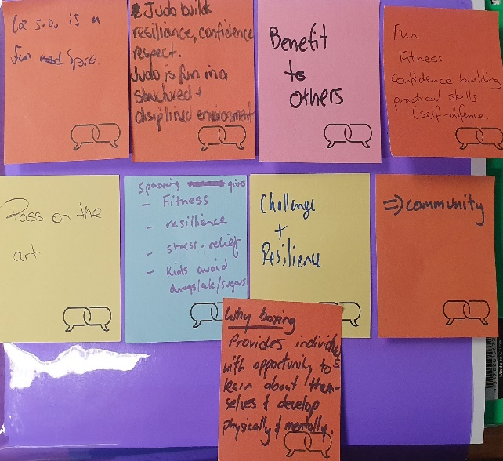
CONTROLLED SPORTS IN THE ACT
The ACT Government – Chief Minister, Treasury and Economic Development Directorate recently sought stakeholder input to subordinate legislation being developed under the Controlled Sports Act 2019 (the Act). This legislation regulates combat sports events in the ACT for safety and integrity purposes.
Subordinate Legislation that will support the Act is being developed. Stakeholders were asked for input on the following:
- Establishment of a minimum age for participation in controlled sports events
- An industry code of practice, applicable to both registrable and non-registrable events
- Arrangements for non-registrable events including:
  - How to become an Authorised Controlled Sports Body
  - Requirements that must be met for Authorised Controlled Sports Bodies to approve non-registrable events
  - Notification requirements for non-registrable events
Industry stakeholders were invited to review two policies relating to components of the legislation that have been raised in previous consultations. These are:
- The Commercial Purpose Policy - this policy explains how commercial purpose will be determined in distinguishing between registrable and non-registrable events.
- The Light Contact Combat Sports Exemption Policy - this policy explains how to apply for exemption as a light contact combat sport under Section 8 of the Act.

THE CONVERSATION
The conversation took place across a range of activities to consult industry representatives, young athletes, and parents and carers.
Two industry workshops, three youth workshops, and an online parents and carers survey were undertaken between 1 June – 2 July 2019. Written submissions were also provided.

WHO ENGAGED
Feedback was received from representatives of 17 different controlled sports, representing industry, young athletes, and parents and carers.
Industry workshops were attended by 14 industry representatives (representing sporting organisations, promoters, organisers and gyms), three young combat sport athletes attended a dedicated youth workshop, six written submissions were received from industry, parents and young people and 216 parent and carer survey responses were received.
Key insights from the community
Benefits and risk
- There is a strong combat sports community with a keen understanding of the risks and benefits that arise from their involvement in combat sport activities
- Individual sports have a number of risk management practices already in place
- Feedback indicated mixed views on the impacts this legislation would have on identified risks and benefits.
Establishing a minimum age for participation in controlled sports events
- Of the four options presented, there was no overwhelmingly preferred option
- Option 4 (minimum age set at 14 years with prohibition on contact with the head, neck, spine or groin under this age BUT allow individual athletes to apply for an exemption based on elite or promising athlete status) received the most negative feedback
- All other options received mixed feedback across the different feedback channels
- Feedback in this area was mixed, some commonly highlighted feedback included:
- concern expressed that an age limit of 14 would conflict with national/international rules
- a 14 year age limit may hamper progression and the talent pool available for competitions
- the minimum age needs to also be reflective of the mitigation measures already in place
Code of Practice
- Feedback was received on the Code of Practice in both the ‘Matters relating to registrable events’ and ‘Matters relating to non-registrable events’ sections.
- Suggestions were made on contest rules, promoter responsibilities, medical requirements, insurance, protective clothing and equipment, matchmaking, international contestants, weight cutting, doping, weigh-ins, and contest area requirements
- A range of additional inclusions for the Code of Practice were also suggested.
Authorised Controlled Sports Bodies and non-registrable events
- Minimal feedback was received on conditions for becoming an Authorised Controlled Sports Body; however focus was given to the application of the commercial purposes policy and the impacts this could have on fundraising activities
- Consistent feedback was received relating to areas where proposed notification requirements for non-registrable events would pose a challenge; including interclub competitions, lead-times for draws and registration, and detailed participant and attendee information.
Broader feedback
- A range of broader feedback was also received that related to the language and terminology used in documentation; the role of the new inspectors; the application of the legislation to combat sports specifically; the consultation process and the role of industry in informing and enforcing the legislation.

What’s Next?
The feedback received during this consultation will be used to inform the final content of the subordinate legislation and policies that will support the Controlled Sports Act 2019.
The Controlled Sports Act 2019 has now passed and the scheme is due to commence on 11 October 2019. To get to that date, the following activities need to occur
- Preparing to transition administration of scheme to Access Canberra for Registrations & Inspectorate functions
- Finalise the subordinate legislation & regulations e.g. Code of Practice (which this consultation will inform)
You can register to receive project updates by contacting controlledsports@act.gov.au
To find out more about controlled sports in the ACT visit https://www.sport.act.gov.au/clubs-and-organisations/combat-sport-applications

THANK YOU FOR YOUR FEEDBACK
93  Combat sport organisations, promoters, organisers and gyms were directly approached to participate | 17  We spoke to 17 individuals | 3  We delivered 3 presentations to 17 people | 216  We received 216 survey responses from the parents and carers survey
6  We received 6 written submissions via email | 36  We received survey responses from 32 ACT suburbs and nearby towns; and four from other towns in NSW and Victoria | 17  Feedback from representatives of 17 different controlled sports was heard during the consultation | 56%  of survey respondents had more than one child who participated in combat sports

