  - Controlled Sports subordinate legislation development

  - Stakeholder consultation report
FINAL
12 July 2019

Contents
1. Introduction 3
2. Promotion and participation 4
3. Industry and youth workshops 5
3.1 Industry workshops 5
3.2 Youth workshops 6
4. Parent and carer survey and written submissions 7
4.1 Written submissions 7
4.2 Survey responses 7
5. Establishing a minimum age 8
5.1 Risks and benefits 8
5.2 Option specific feedback 12
5.2.1 Option 1 12
5.2.2 Option 2 13
5.2.3 Option 3 14
5.2.4 Option 4 15
5.2.5 Suggested alternative options 16
6. Code of Practice 17
7. Authorised Controlled Sports Bodies and non-registrable events 18
7.1 Becoming an Authorised Controlled Sports Body 18
7.2 Conditions for approval of non-registrable events 18
7.3 Notifications requirements for non-registrable events 18
7.4 Commercial Purpose Policy 18
8. Broader feedback 20
Appendices 21
Appendix A – Industry worksheets 21
Appendix B – Letters to the Sports Minister 25
Appendix C – Code of Practice feedback 26
Appendix D – Summary of written submissions 30
Appendix E – Survey results 33
- Introduction
The ACT Government – Chief Minister, Treasury and Economic Development Directorate recently sought stakeholder input to regulations being developed under the Controlled Sports Act 2019 (the Act). This legislation regulates combat sports events in the ACT for safety and integrity purposes.
Legislation that will support the Act is being developed. Stakeholders were asked to provide their input on the following:
- Establishment of a minimum age for participation in controlled sports events
- An industry code of practice, applicable to both registrable and non-registrable events
- Arrangements for non-registrable events including:
  - How to become an Authorised Controlled Sports Body
  - Requirements that must be met for Authorised Controlled Sports Bodies to approve non-registrable events
  - Notification requirements for non-registrable events
Industry stakeholders were also invited to review two policies relating to components of the legislation that have been raised in previous consultations. These are:
- The Commercial Purpose Policy - this policy explains how commercial purpose will be determined in distinguishing between registrable and non-registrable events.
- The Light Contact Combat Sports Exemption Policy - this policy explains how to apply for exemption as a light contact combat sport under Section 8 of the Act.
The Light Contact Combat Sports Exemption Policy did not form part of the consultation framework at the industry workshops.
Communication Link was engaged to deliver industry workshops to seek feedback on all areas and youth workshops to inform the establishment of a minimum age. Two industry workshops were held on 18 June and 27 June 2019. Three youth workshops were offered on 18, 20 and 25 June 2019.
In conjunction with this engagement, the ACT Government ran an online survey for parents to gather feedback on the establishment of a minimum age for participation in combat sports events. Feedback was also provided directly through email submissions. Feedback from the survey and from email submissions are also reflected in this report.
This report provides an overview of the consultation activities and provides detail of feedback received on each of the input areas.
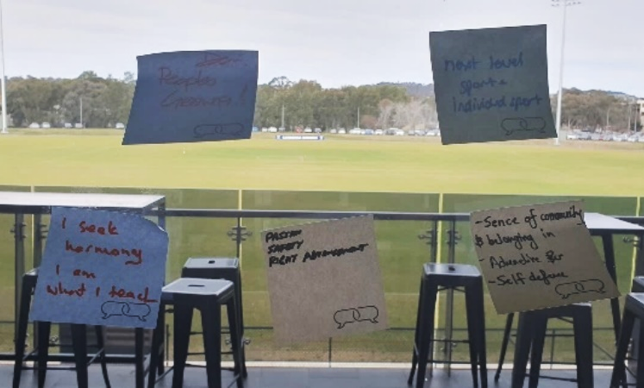

- Promotion and participation
To inform the consultation process, the ACT Government made available the following documentation on their website (https://www.sport.act.gov.au/clubs-and-organisations/combat-sport-applications/consultation-on-regulations):
- Factsheets on:
  - Code of Practice
  - Establishment of a minimum age for participation in controlled sports events
  - Arrangements for non-registrable events
  - requirements for Authorised Controlled Sports Bodies, including how to become authorised, conditions of authorisation and requirements for notification of events.
- Draft Code of Practice
- Draft Light Contact Combat Sports Exemption Policy
- Draft Commercial Purpose Policy (for registrable events)
Ninety-three combat sports organisations, promoters and gyms were directly approached to provide feedback to the consultation. In addition, gyms were asked to promote the parent and carer survey, and children’s sessions to their patrons. A poster was supplied to erect on club notice boards. The ACT Government also promoted the consultation through the Sport and Recreation website as well as various social media channels, including the Sport and Recreation Facebook page and ACT Government Facebook page. A post to the ACT Government Facebook page generated significant interest in the parent and carer survey, lifting the results by 133 valid responses.

Table 1 shows a summary of the consultation events held and the attendees at each.
- Participation numbers for consultation events
Event type | Participation
Industry session, 18 June, 12.30pm – 2.30pm, Phillip ACT | Five industry representatives
Industry session, 27 June, 12pm – 2pm, Bruce ACT | Nine industry representatives
Youth session, 18 June, 4.30pm – 5.30pm, Weston Creek ACT | No attendees
Youth session, 20 June, 3.30pm – 4.30pm, Tuggeranong ACT | Three youth participants
Youth session, 25 June, 4pm – 5pm, Gungahlin ACT | No attendees
Parent and carer survey (online from 1 June – 2 July 2019) | 216 responses
Email feedback | Six submissions
- Industry and youth workshops
  - Industry workshops
Industry workshops were held on 18 June, 12.30pm – 2.30pm in Phillip ACT and 27 June, 12pm – 2pm in Bruce ACT. A total of 14 participants attended both sessions.
Participants were given a presentation from Rebecca Kelley, Executive Branch Manager, Sport and Recreation on the workshop purpose and background. Following this were four sessions:
- Session 1: Managing risks and maximising benefits
- Session 2: Options for establishing a minimum age
- Session 3: Code of practice
- Session 4: Authorised Controlled Sports Bodies and non-registrable events
Participants were also asked the following questions “what is it about your sport that makes you continue to be involved?” and “why do you do what you do?”. A word cloud of these responses is shown in Figure 1.
- Individual outcomes of combat sport participation. Larger word size indicates higher frequency of occurrence in responses.

Workshop participants represented the following sports:
- Judo
- Kendo
- Boxing
- Mixed Martial Arts (MMA)
- Jujitsu
- Karate
- Hapkido
- Taekwondo
- Kyusho Jitsu
  - Youth workshops
Three youth workshops were also offered, although only one of these was attended. Three young combat sport participants attended the youth workshop on 20 June, 3.30pm – 4.30pm in Tuggeranong ACT.
The participants were male and female, aged between 13 and 15 and represented MMA and Brazilian Jujitsu.
When asked why they were involved in their sport of choice, responses included:
“I like it because I’ve always had interest and long term benefits of self-defence”
“I need to do it as there is nothing else I want to do, and it’s a big part of who I am and what I want to do for the rest of my life”
“I like it because of the mixed environment and culture. I’ve grown up around it from the age of 6.”
The workshop focused on gathering feedback on the establishment of a minimum age for participation in competitions.
Participants were asked to define risks and benefits and were asked to identify risks, benefits and their management within their sports. Participants were also asked to provide feedback on each of the options for the establishment of a minimum age put forward by the ACT Government.
The workshop concluded with participants being asked to write a fictional letter to the Sports Minister to answer the question “If you could say one thing to the Sports Minister about this consultation, what would it be?” The letters offered some feedback on the proposed age restrictions, but they largely focused on the existing age restrictions that preclude under 18 MMA fighters from fighting in cages. Currently under 18s can only fight in boxing rings. Feedback highlighted that this added dangers as the ring is hard, the wrong surface, fighters have fallen out of the ring and the ropes can’t bare the weight of two people fighting against it. It was also noted that current changes in NSW are allowing certain sports to move into cages. The letters are included at Appendix B.

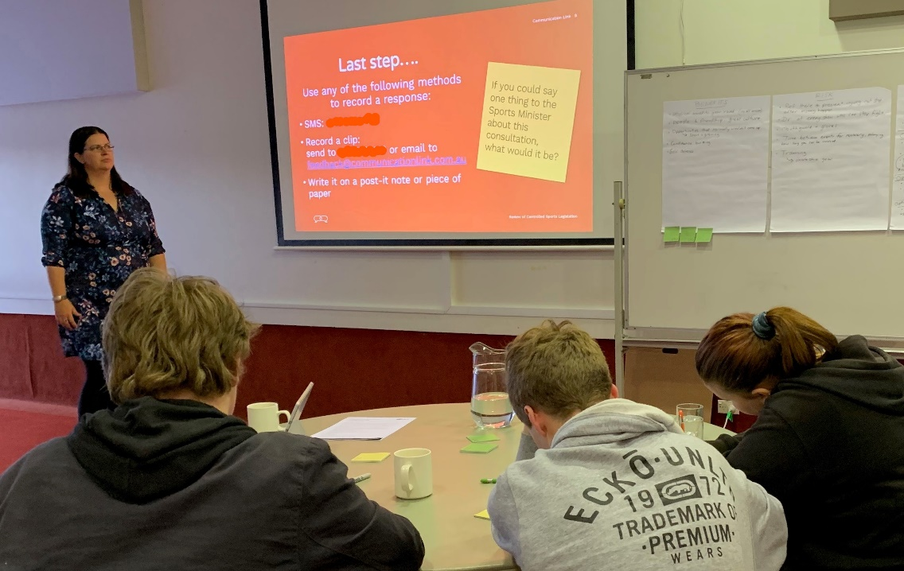
- Participants writing letters to the Minister

- Parent and carer survey and written submissions
The ACT Government survey sought parent and carer views on the establishment of a minimum age for participation in controlled sports events. The survey was available online from 1 June to 2 July 2019. In addition, six written submissions were received.
  - Written submissions
Written submission feedback included a combination of individual stories and parent/carer experiences in combat sports (including what has been gained from these experiences); feedback on the draft Code of Practice and other policy documents; and specific feedback on the proposed minimum age options. A summary of each submission can be found in Appendix D.
  - Survey responses
Communication Link has undertaken analysis of the survey results and written submissions. The survey received 216 responses. Of these 216 responses, 82 respondents were not parents or carers and were not permitted to finish the survey, survey response numbers were not adjusted to allow for this. This resulted in the number of non-responses looking particularly high for some questions as the number on non-responses still includes the 82 people who were not able to complete the survey.
The survey analysis included quantification of a large volume of open-ended responses. These quantified responses were then merged with the pre-existing questions responses to enable statistical analysis of the feedback. Full details of the survey outcomes can be found at Appendix E.
Survey question 20 has not been included in this analysis for reasons of data integrity. Question 20 asked “To what extent do you agree or disagree that the safety of children under 14 years of age would improve if techniques that make contact with the head, neck spine or groin are restricted during contests?” The answers offered for this question were entered incorrectly, resulting in a repeated option to agree or strongly agree rather than providing the option to disagree or strongly disagree. This was corrected on 27 June 2019 at 9pm. However, as the integrity of these answers was compromised, they have not been included in this report.
Feedback from the parent and carer survey and email feedback has been incorporated into the relevant sections of this report. Key highlights from the survey can be found below.
Nearly 2/3 of survey respondents were male | 56% of respondents had more than one child who participated in combat sports | Responses were received from 32 ACT suburbs and nearby towns. | 16 combat sports were represented in the survey results
- Establishing a minimum age
All consultation activities sought participant feedback on the establishment of a minimum age for participation in controlled sports events. Consultation questions relating to this were:
- How you (in whatever capacity) manage risks of significant injury in sports participation
- Your understanding of the risks of injury in combat sports and how these are managed
- Any industry specific feedback regarding the design, structure and content of a regulation on minimum age
- The similarities and differences between current contest rules and the proposed options (for industry representatives)
Section 5.1 shows the feedback received relating to questions one and two. Section 5.2 addresses the responses received relating to questions three and four.
  - Risks and benefits
Participants were asked across both industry and youth workshops, online survey to identify the risks and benefits they associated with being a part of their sport. Participants were also asked to identify ways of managing risk and maximising the benefits involved in their sports.
Table 2 shows recurrent themes heard for risk, risk management, benefits and maximising benefits across each of the feedback channels.

 | INDUSTRY WORKSHOPS | YOUTH WORKSHOP | ONLINE SURVEY | WRITTEN SUBMISSIONS
RISKS | - Injuries (contact injuries, head injuries, breaks, concussion, sprains and tears)  - Death  - Competition environment  - Lack of education  - Capability of people  - Experience/skill matching  - Reputation (Code of Practice, standards, creating right environment)  - Financial damage (insurance)  - Competence of officials (certification)  - Inconsistent application of rules/regulations  - Weight cutting  - Doping/drugs | - Risks were only identified in the context of risk management strategies | - Mental  - Physical pain/injury  - Social  - Same as other sports  - None  - Stigma  - Poor Instruction  - Over-training  - Parental-factors
RISK MANAGEMENT | - Accredited coaching/ instructors/ officials (including medical)  - Existing codes of practice/ legislation / regulation / national and international rules  - Insurance  - Education/ awareness  - Mentor system/ testing  - Medical clearance  - Match making  - Athlete experience  - Equipment (checked and approved)  - Use checklist  - Training  - Assessment of skills  - Techniques (eg. break fall and tap outs)  - Strict rules on submission and choke techniques  - Respectful culture  - Doping/ drugs (testing/ laws/ compliance/ international oversight  - Weight cutting (training/ education, monitoring over time, medical inspections and doctors)  - Existing age/skill restrictions on certain techniques and ability to compete  - Risk management process built into Association  - Breaks between matches  - Warm-ups/cool downs | - Protective equipment used (mouthguards, gloves, shin guards) in competition and training  - In MMA, referee is there to prevent injury, not just stop after injury has happened  - Doctor present at every show that can stop the fight if they believe the people are too injured to continue  - Breaks between competition (only a few times a year) | - Over 35% of respondents felt that current risk management practices were sufficient | - Good coaching  - Appropriate training to learn correct techniques  - Medical staff present at competitions  - First aid training of coaches
BENEFITS | - Sense of community/ belonging/friendship  - Self-defense  - Builds confidence and resilience  - Stress management  - Ethics/ respect for others (Value system common across most martial arts)  - Personal development for athletes and officials (continuous learning, skills for life, skills transference to school and workplace, resilience, stress management)  - Legacy for next generation  - Fitness (agility, balance, flexibility)  - Self-discipline – control of emotions  - Gross motor skills  - Divert from bullying and antisocial behavior  - Safely tumbling and falling  - Role models for elite competition | - Physical benefits from training all year round.  - Great environment and culture  - Opportunity creation  - Confidence building | - Self Defence  - Health  - Social  - Behaviour  - Mental health  - Competition  - Mental skills  - Injury prevention  - Aggression outlet  - Away from electronics  - Fun  - Spiritual/Cultural  - Mentorship | - Teaches respect  - Teaches determination  - Increases self-esteem and self-confidence  - Opportunities for international travel  - Teaches discipline and self-control  - Attain life skills and transferable skills  - Improved understanding of nutrition and the importance of exercise  - Avoid negative factors such as drugs and alcohol  - Keeps kids active  - Lower injury rate than other sports such as skating, rugby and motorbike riding  - Fitness and personal development benefits
MAXIMISING BENEFITS | - Accreditation  - Code of practice  - Being successful  - Consistency – same page  - Give back, next generation, legacy  - Less regulation that does not fit the sport  - Less regulation that imposes additional costs to compete  - Sports controlled by well-managed bodies with clearly defined rules, processes and governance | - Discussion focused primarily on identifying benefits

  - Option specific feedback
To further inform the discussion on consultation questions three and four, four options for the establishment of a minimum age were presented and feedback was sought on the positives and negatives of each option. These options are shown in Figure 3.
In the industry workshops, participants were asked to vote for the option they preferred. In the first industry workshop, option three received the most votes. In the second industry workshop, none of the options received a vote. Instead the group suggested alternative options which received their votes. The most voted for options for the second workshop were:
- Leave industry to self-regulate
- No minimum age
- Options for establishment of minimum age

    - Option 1 – Prohibit children under 14 years from using techniques that have contact with the head, neck spine or groin
      - INDUSTRY FEEDBACK
Below is a summary of positive and negative feedback on option 1 received from industry workshops and email submissions.

Positive
- Good that it is clear/hard rule
- All other options provide grey area where people can manipulate – option 1 doesn’t

Negative
- May conflict with international/ national rules
- Younger people should be able to compete but not with head contact
- The 14 year age limit seems arbitrary
- Definition includes a throw – this is too limiting for Judo
- Abide by national and international body rules – this will not enable kids to move up in a national and international level
- The same age should not apply to all sports
- A 14 year age limit will mean that athletes will not gain competition experience for international competition
- Does not include consideration of all the mitigations already in place
- A lot of work has been done to create athlete pathways (including an increased focus on young female participation) - competency must be proven before progressing – a 14 year age limit does not consider this
      - YOUTH FEEDBACK
Below is a summary of positive and negative feedback on option 1 received from the youth workshop.

Positive
- Positive in some areas
- Age 14 as far as a blanket statement is a good age for who can and can’t fight.

Negative
- In some cases for those who have a career in this field you need to start early to gain that experience. It can take a long time to get the experience that you need.
- Under 14s should be allowed to compete but a lot of sport’s rules would need to be modified for each sport.
      - PARENT AND CARER SURVEY FEEDBACK
The survey question relating to this option (question 15) did not specifically highlight the age restriction as 14, however the suggestion of introducing prohibited techniques was opposed by over 50% of respondents.
When asked what the impact would be on their children if an age restriction to 14 was established, the top four responses were:
- It won’t change anything (23.1% of responses)
- My child/ children will be less likely to participate in contests (22.6% of responses)
- My child/ children will not be able/ allowed to participate in contests (17.9% of responses)
- This won't apply to my child/ children (14.1% of responses)

    - Option 2 – Minimum age to vary across different controlled sports. Decision to be made by the Minister and advisory committee
      - INDUSTRY FEEDBACK

Below is a summary of positive and negative feedback on option 2 received from industry workshops and email submissions.

Positive
- Empowers individual sports – sports directed outcome
- Could enable sport specific rules – eg. Competing in an ‘open mat’ environment
- Guided by and aligned to existing rules (including international rules and existing age restrictions)
- Option 1 is a simple solution, but this may be more fit for purpose
- Would enable modified rules to be includes such as precluding head strikes
- Might work but bodies will be all different
- Not supported as this does not provide enough checks and balances

Negative
- May create ‘loop holes’ that promoters can work around eg: name of event
- Commercial events must be over 18 – motivations are changed by commercial environment
- Unnecessary as strong community, parents, ethics and national structures will keep the bad guys out
- Unknown impacts on emerging sports
- Exemption goes to the organisation that is organising the event – needs to be done under the representative group
- International rule is 10 for many sports – why need another set of rules?
      - YOUTH FEEDBACK

Below is a summary of feedback on option 2 received from the youth workshop. No positive feedback was received on this option.

Negative
- Decisions should only be made by a representative from that sport, for example: an MMA fighter cannot decide what age someone can box.
- The Minister could be influenced by parents whose children play the sport by making the most noise.
- What information will the Minister receive to make this decision? Will it be enough to make a decision?
- How would the advisory committee be chosen? If it’s from the Sports Commission, they aren’t coming from combat sport. Not sure how they can make their decisions, they would have very little information. Advisory committee may not have perspective on the combat sports.
      - PARENT AND CARER SURVEY FEEDBACK
The survey question relating to this option (question 16) asked to what extent did respondents agree or disagree with the following statement “Sporting organisations should be able to set their own minimum age for participation in their style of combat sport”.
Over 84% of respondents either agreed or strongly agreed with this statement.

    - Option 3 – Prohibit children under 14 years from using techniques that have contact with the head, neck spine or groin BUT allow sporting organisations to apply for an exemption for non-registrable events
      - INDUSTRY FEEDBACK

Below is a summary of positive and negative feedback on option 3 received from industry workshops and email submissions.

Positive
- More streamlined than option 4
- This is more applicable than option 4
- Option 3 would work much better than option 4 but promoters/event coordinators could provide assurances on behalf of participants
- Offers flexibility for different sports and includes more safeguards.
- The Authorised Controlled Sports Body must supply more evidence than in option 2.
- The possibility of confusion for officials dealing with inconsistency between different codes is not considered of paramount importance, as any official should be able to demonstrate expertise in the code at which they are officiating.

Negative
- Exemptions should be allowed for light contact rules, protective equipment, international guidelines/ rules and modified rules
- Different sports have different rules and types of different equipment required to protect young people.
- Graduated contact levels – does this occur in most levels? Modified rules.
- Having a properly governed organisation mean that options 2 and 3 are quite similar

      - YOUTH FEEDBACK

Below is a summary of feedback on option 3 received from the youth workshop. No positive feedback was received on this option.

Negative
- The promotors might not have the same motivations as us.
- If someone was 12 and wanted to compete in kick boxing and got approval, they may not be able to find someone else at the same weight due to the exemption process. That could lead to a 12-year-old fighting with a 16-year-old because there was no one else to fight with.

      - PARENT AND CARER SURVEY FEEDBACK
The survey question relating to this option (question 16) asked to what extent did respondents agree or disagree with the following statement “Sporting organisations should be able to apply for an exemption for their contestants under 14 years of age, to use techniques involving contact with the head, neck, spine or groin”.
Over 60% of respondents either agreed or strongly agreed with this statement.

    - Option 4 – Prohibit children under 14 years from using techniques that have contact with the head, neck spine or groin BUT allow individual athletes to apply for an exemption based on elite or promising athlete status
      - INDUSTRY FEEDBACK
Below is a summary of feedback on option 4 received from industry workshops and email submissions. No positive feedback was received on this option. This option was not discussed at one industry workshop as all agreed that it would not work.

Negative
- If athletes aren’t able to compete until they are 14, there won’t be any elite athletes
- Restricts emerging athletes
- The term ‘elite’ does not really apply in this context
- Most gifted athletes get identified at competitions not in the gym, so they won’t be able to be identified if they can’t compete first
- Whether you are elite or not, this does not minimise the impact of a blow to the head.

      - YOUTH FEEDBACK

Below is a summary of feedback on option 4 received from the youth workshop. No positive feedback was received on this option.
- Parents may push their kids even if they aren’t elite
- Similar to option 3, only allowing people to compete by exception will mean that you will not have kids at the same weight, age and sport to compete against
- Could end very poorly.
- The fighter shouldn’t decide whether they can fight. It could lead to injury and harm.

      - PARENT AND CARER SURVEY FEEDBACK
The survey question relating to this option (question 16) asked to what extent did respondents agree or disagree with the following statement “Individual athletes, under 14 years of age that are considered an elite or promising athlete, should be able to apply for an exemption so they can use prohibited techniques involving contact with the head, neck, spine or groin”.
Just over half (56%) of respondents either agreed or strongly agreed with this statement.

    - Suggested alternative options
Alternative suggestions received during an industry workshops were as follows:
- If an event has insurance than if should be able to proceed
- Leave industry to self-regulate
- No minimum age.
When participants at this industry workshop were asked to vote for their preferred option based on the four options supplied and these options, 80% of the votes went to “leave industry to self-regulate” and 20% of the votes went to “no minimum age”.
Additional feedback received suggested that athletes aged 10-13 should be included in all options and further reinforced that a 14 year ban across most options should be revisited.

- Code of Practice
Feedback received on the draft Code of Practice was gathered from industry workshops and from written submissions. A summary of the feedback received is included at Appendix C.
Table 3 shows the areas feedback was received on both sections of the draft Code of Practice.
- Sections of the draft Code of Practice that received feedback
Applications for registrable events | Applications for non-registrable events
Contest Rules | Contest rules
Promoter Responsibilities | Medical requirements
Insurance | Protective Clothing and Equipment
Matchmaking
International Contestants
Weight cutting
Doping
Weigh-Ins
Contest area requirements
Protective Clothing and Equipment

In addition to this specific feedback, additional feedback was received of a general nature. Most of this feedback related to ensuring that the implementation of the changes to the controlled sports legislation is accompanied by an education program to ensure changes are understood.
In addition to this, other comments related to:
- Restricting photos of juniors at weigh-ins
- Provision of private areas for weigh-ins
- Notifying AFP of the event, time, location and expected crowd
- Recognition could be given as a certified/Code of Practice participant
- The terminology used in the Code of Practice is not relevant to all sports and remains boxing focused
- Feedback received indicated that feedback given last year had not been incorporated into draft Code of Practice
- Confusion around the distinction between registrable and non-registrable events.

- Authorised Controlled Sports Bodies and non-registrable events
Feedback was received through industry workshops and written submissions on conditions for becoming an Authorised Controlled Sports Body and on the conditions for non-registrable events being approved for Authorised Controlled Sports Bodies. Feedback was also received on the notification requirements for non-registrable events.
  - Becoming an Authorised Controlled Sports Body
Feedback relating to the process of becoming an Authorised Controlled Sports Body was minimal. Most feedback related to the application of the Commercial purposes policy (discussed in section 7.4) and the resulting impacts this would have on events deemed to be ‘commercial’ when the intent was for ‘fundraising’ not ‘profit-making’ activity. Boxing was used as an example in this context. There was also some confusion about whether a representative organisation would receive automatic recognition as an Authorised Controlled Sports Body if they were affiliated under an NSO but not the NSO itself.
Other feedback received suggested that becoming an Authorised Controlled Sports Body should not be required if the event was held under the sanction of a National Sporting Organisation (NSO). This would put the responsibility to ensure that all requirements were being met onto the NSO.
It was also noted that communication around the date when applications (if the proposal came into force) would open was very important to allow sports to undertake appropriate planning.
  - Conditions for approval of non-registrable events
It was suggested that if an event was ‘sanctioned’ by an NSO eg. Boxing ACT, it should be non-registrable.
  - Notifications requirements for non-registrable events
Consistent feedback was received relating to areas where proposed notification requirements for non-registrable events would pose a challenge. These included:
- Understanding who would be responsible for notification for interclub competitions
- Lead-times before events. Feedback was received that in some instances entry to a competition may only open a week or information is not known until the event is occurring, making a 28 day notification impossible
- It was suggested that a notification of the event date could be made with detailed participant and attendee information to follow closer to the event
- It was also suggested that the inspector will be able to ensure compliance with requirements on the ground instead and that detail could be provided after the event
- Understanding where an unaffiliated club with no NSO would fit is important
  - Commercial Purpose Policy
The intent and detail of the Commercial Purpose Policy was discussed at the industry workshop and noted in a written submission.
Discussion on this policy focused on the definition of commercial. The intent of charging for the event was discussed and consideration was given as to whether the intent of the event was to make money for profit, or if the intent is more focused on fundraising to reinvest in the club for equipment or athlete travel.
The suggestion was also made that an organisation’s ‘not for profit’ status with the ATO could be used to determine their eligibility under this policy – irrespective of whether they were an Authorised Controlled Sports Body.
Feedback was also received that in NSW the event is categorised as professional or amateur depending on whether spectators pay to watch. If no payment is required, then it is considered amateur. In addition, if the event takes place in a ring or a cage, it is registrable.
Additional feedback also suggested that any event where betting was taking place should not be considered non-registrable.
For some sports, the commercial nature of their events meant that under the proposed Commercial Purpose Policy their events would be registrable. Feedback received from these groups suggested that the current proposal would limit their ability to provide practice competitions for their athletes or make money to reinvest in their gyms or studios.

- Broader feedback
During the consultation, additional feedback was received that related to the controlled sports legislation more broadly. Table 4 captures this feedback.
- Feedback received that did not specifically relate to highlighted consultation areas
Feedback area | Feedback detail
Language used in documentation | Discussion around the terminology was raised in both industry workshops. Points to note include:  - Confusion around the terms ‘registrable’ and ‘non-registrable’  - The term ‘promoter’ was very boing specific and should be changed to ‘organiser’  - The language used across the documentation was not inclusive of the sports that it covers and appeared very boxing-centric.
Role of inspectors | Clarification was sought on multiple occasions on the role of inspectors, seeking to understand where they would be sourced from, the role they would perform and whether they would have knowledge of the sports they are inspecting. Consistent feedback indicated that inspectors should have relevant controlled sports experience and should be accompanied by someone from the industry body. Inspectors should have an individual sport focus.
Broad and narrow focus | There was recurring feedback that the scope of the legislation aimed to take in too many different sports, resulting in documentation that was too prescriptive or inaccurate for some sports.  Conversely, feedback was also received that questioned why the legislation was not broader to include other contact sports such as AFL, rugby league, rugby union and soccer.
Consultation process | Feedback was received through industry workshops and written submissions that suggested feedback from previous consultations had not been integrated into revised documentation. This feedback specifically related to changes to the Code of Practice but was also provided more generally.  Concern was also raised that the minimum age of 14 had not been mentioned in any previous consultation and the reasons for its selection were not highlighted comprehensively.
Informed by industry | It was suggested that the project team should undertake field work across the range of different sports prior to finalising the updates.  It was also suggested that industry should be able to manage itself and suggestions were made that included consideration of an independent accreditation process for officials and coaches to increase safety and minimise the use of combat sports events being used for illegal activities.

Appendices
- Industry worksheets

Workshop 1
Managing risks | Maximising benefits
List some of the risks associated with your sport  Injuries and death  Reputational damage  Financial damage | List some of the benefits associated with your sport  Healthy population  Sense of community/ belonging  Self-defense/ confidence  Ethics/ respect for others
How are these risks managed?  Accredited coaching/ instructors/ officials  Codes of practice/ legislation  Insurance | How can these benefits be maximised?  Accreditation  Code of practice  Being successful

Managing risks | Maximising benefits
List some of the risks associated with your sport  - Head trauma – injuries  - Capability  - Environment  - Safety  - Competence of officials (certification)  - Accountability  - Consistency. | List some of the benefits associated with your sport  - Personal development (athlete, officials etc)  - Continuous learning  - Skills for life  - learning
How are these risks managed?  - Doctor, judges, referee  - Education/ awareness  - Action  - Mentor system/ testing  - Medical clearance  - Match making – check skill level match appropriately  - Experience (combatant/ athlete)  - Equipment promoter  - Use checklist  - Regulations of sport | How can these benefits be maximised?  - Consistency – same page  - Give back, next generation, legacy

Workshop 2
Managing risks | Maximising benefits
List some of the risks associated with your sport  - As in any physical sport, injury is of course a risk, but rules and training are designed to minimise. | List some of the benefits associated with your sport  - Fitness and flexibility  - Control  - Discipline  - Safely tumbling and falling  - Olympic sport  - Allows children to compete and aspire to elite competition by starting to develop required skills and experience early
How are these risks managed?  - Age requirements for under 12s eg. No drop throws, no neck holds, no arm bars  - Strict rules on submission and choke techniques  - Compliance with national and international rule sets  - Risk management process built into Association  - Medical onsite at major competitions  - Referees control competition bouts  - Can’t compete until at certain kyu (belt) level | How can these benefits be maximised?  - Less regulation that does not fit the sport  - Less regulation that imposes additional costs to compete

Managing risks | Maximising benefits
List some of the risks associated with your sport  - Contact injuries concussion etc  - noting a 12 year old punching another 12 year old applies a lot less force than a tackle at speed, or involving several other players. | List some of the benefits associated with your sport  - Fitness benefits (children at greater risk of diabetes and sedentary illness through inactivity)  - Resilience and discipline  - Stress management  - Coaching and role modelling  - Confidence  - Diversion from bullying and anti-social behaviour.
How are these risks managed?  - Referees and rules (1 minute rounds for younger boxers)  - Matching (young people matching in boxing within 24mths and 2kgs and similar experience)  - Breaks between matches  - Doctor supervises the bout  - Equipment, padded gloves  - 8 counts  - Preparation in gym before coach agrees to compete  - Competitors motivated to show skill and techniques, judged on skill and techniques | How can these benefits be maximised?  - Sports controlled by well-managed bodies with clearly defined rules, processes and governance.

Managing risks | Maximising benefits
List some of the risks associated with your sport  - Note the onus here (referring to the title ‘your sport’)  - Kendo  - Sprains and tears  - Occasional contact injury in competitions  - Wrestling  - Sprains  - Breaks  - Concussion  - Doping  - ASC, IOC, Comm games | List some of the benefits associated with your sport  - Kendo  - Self-discipline  - Awareness and consideration of others  - Health  - Community (Canberra/Nara)  - Friendship (international)  - All defined by ‘concept of KENDO’  - Wrestling  - Olympics/national reps  - Fitness  - Community
How are these risks managed?  - Kendo  - Warm-ups/cool downs  - Coach training  - Teaching of proper techniques in line with National (AKR) and International guidelines (FIK)  - 3 referees on each court and 1 court judge (+ first aid and medical)  - Accredited by being a member of a National body  - Wrestling  - Age/size classes  - Refs (trained)  - Medical staff  - Soft mats  - Intensive training  - Coach accreditation  - Opponent is not meant to be injured  - ASADA | How can these benefits be maximised?  - Kendo  - Work with ACTAS to help you understand what we already have in place so we don’t get buried in red tape and lose members  - Wrestling  - Many competitions since young age  - High level comps  - Lots of training

Managing risks | Maximising benefits
List some of the risks associated with your sport  - Impact injuries due to falls or strive  - Sprains associated with joint locks | List some of the benefits associated with your sport  - Fitness  - Strength  - Flexibility  - Fun  - Stress control  - Self-defence (self and others)  - Positive attitude  - Respect for others
How are these risks managed?  - We teach break falls – how to fall safely to the ground  - Mats equivalent  - We teach control and how to receive a technique – not just crashing to the floor – rugby tackle  - We teach ‘tap out’ ie. when it starts to hurt you indicate to stop.  - We teach mutual respect. “Be Master of Yourself”  - Techniques are practices with mutual consent. | How can these benefits be maximised?  - This has been a traditional and integral part of MA (Japanese) for centuries.  - This gets passed on as students learn the art.
- Letters to the Sports Minister (from Youth Workshop)

Response 1
Under 18s should be allowed to compete in the cage as long as there is appropriate safety requirements such as a doctor, and a referee that is worried about the fighters safety.
Mixed martial arts events should be held in a cage it’s a lot safer than a boxing ring because ¼ of the rules in MMA uses the cage and it’s also better because if a fighter was going for a takedown, throw or a slam they could potentially fall out of the ring resulting in major injury but if it’s in a cage that threat is gone.

Response 2
Under 18 Mixed Martial Arts fighters are currently not allowed to compete in a cage (have to fight in a ring).
This is because people’s poor perspective on MMA.
It is very dangerous to fight in a ring. The mat is very thin and not designed to have people falling or hitting the ground. There is also the lack of support of cage walls. MMA fighters have fallen out of the ring, broken their hand accidently hitting the mat. Combat sports has evolved from putting underage fighters in dangerous positions only because of the view of the sport. Personally I think children under the age of 14 should not compete in head strike heavy sports. Each sport needs to be looked at and developed by people with experience in the sport.

Response 3
Me personally, every show is run different, every sport is different. There are different rules and agreements for every sport, it’s the same with MMA. I think that if you are 14, 15, 16 you should be able to fight in a cage for the MMA fighter because it is honestly so much safer for the fighter that is fighting than in a boxing ring because MMA in a boxing ring you have the risk of being punched out of the ring and are hurting yourself more that way than actually partaking in the fight. Like I said before, every show is set up and ran differently so it would depend on rules for what sport they are doing but there are already rules and mature decision the fighters can agree on before the fight evens takes place. So, the fights feel safer, going and doing something they really do love and want to do.

- Code of Practice feedback
- Feedback related to Code of Conduct registrable events section
Matters relating to registrable events
Code of Conduct Section | Item Number | Feedback received
Applications for Registrable events | 3 | Draws notification is too far out  Draws – settled in 24 hours before competition – can’t do a draw 5 days beforehand.
Contest Rules | 7, 8, 9 | Shouldn’t contradict international/national rules that govern the sports.  - Mandated to run comps alongside international rules  Modified rules should still be included in the Code of Practice – loopholes can still be included under the existing Code of Practice. Inspectorate may cover this off. Inspectorate at non-registrable events as well.
Promoter Responsibilities | 12  13  14  15 | The promoter must supply clean and appropriate weight gloves in very good condition (if any) …  The promoter of the event must provide:  - Two stopwatches/timers  - A stretcher  The promoter of the event must ensure that a contest does not commence, or continue, unless a referee and doctor are present.  The promoter must report to the ACT registrar:  - Any serious injuries or deaths of any contestant immediately by phone, and also for serious injury possibly leading to death.
Insurance | 20 | A promoter is required to provide Worker’s Compensation insurance to any employee including any professional fighter on the show (who is by definition an employee or contractor) – need to be very strict otherwise it will be avoided.
Matchmaking | 21 | Contestant age – Need something about adult vs junior. Permitted age gap? I don’t think anyone under 16 should fight an adult. And 16-18 y/o only to fight people 3 years older.  Assurance of trainer or manager. Parents must sign agreeing to a match for juniors and the rules.  Requirements in table are at odds with national laws.  Can have different belts fighting in judo (you are setting requirements that can’t be applied)  Match people in weight and size – doesn’t work across sports (weight controlled not size)
International Contestants | 2 | International contestant rules too onerous  International competitors may come in short-notice – can’t apply all the medical requirements
Weight cutting | 29 | How are you going to enforce this?  Concerned about fluid restrictions
Doping | 35 | Abide by all ASADA regulations and be open to testing.
Weigh-Ins | 36  37  38, 40 | Amateurs weigh in on the same day – within 8 hours of the event is much safe for weight cut and easy to do. Only pros need 24 hr and it is for marketing of the promoter not the safest athlete. Should also be an option.  Why limit the number of weigh ins and not allow pre-testing  Dis-allowance of shoes and socks does not make sense as people are not trying to go up a grade  Singlets used specifically for weigh-in – too much detail to apply to all sports  We now make everyone weigh in in shorts and a top (for girls), avoiding stripping down.  What about female Islamic competitors?
Contest area requirements | 61  60, 61, 62  65 | Contest area flooring is too specific – so prescriptive.  Regulated and specific spaces. Attach national documents as appendices for each sport.  Judging elevation not right
Protective Clothing and Equipment |  | Equipment safety not relevant to some sports e.g. mouth guards
- Feedback related to Code of Conduct non-registrable events section
Matters relating to non-registrable events
Code of Conduct Section | Item number | Feedback received
Contest rules | 6, 7, 8 | Shouldn’t contradict international/national rules that govern the sports.  - Mandated to run comps alongside international rules  Modified rules should still be included in the Code of Practice – loopholes can still be included under the existing Code of Practice. Inspectorate may cover this off. Inspectorate at non-registrable events as well.
Medical requirements | 43  45  11 | Being able to be forced to see a doctor 24 hours beforehand and medical professionals onsite etc. Why can’t there just be a first aider?  Unrealistic impost  To make sure competitors have a medical certificate to say they’re okay. Wouldn’t happen in rugby.  It is possible that two or more arenas would be utilised at the same time at a non-registrable controlled sport event.  The implication of these sections in the Proposed Code of Practice appears to be that each arena could be regarded as having contests, which would mean that each would need a medical practitioner, and possibly two spinal boards. (It is assumed that only one set of the equipment listed in (11) would be required for the entire event.)  The need for a medical practitioner at each ring side is questioned, and especially the requirement for more than two spinal boards for an event.  Having medical practitioner across each arena makes sense.  Having a defibrillator for each space may be excessive
Protective Clothing and Equipment | 20 | Equipment safety not relevant to some sports e.g. mouth guards

- Summary of written submissions
Submission 1
Started doing Muay Thai at the age of 5, currently 13. Benefits of the sport include teaching of respect, determination and self-confidence. Has travelled internationally and has Australian, Oceanic and world titles.
The discipline and self-control taught through the sport has also provided benefits at school both academically and in sport. Improved understanding of nutrition and the importance of exercise, as well as avoiding negative factors such as drugs and alcohol.
Being able to fight is an important part of training and is concerned that rules don’t limit opportunities for other young people to do well at Muay Thai.
Submission 2A
Pleased to legislation being passed with respect to Combat Sports. Providing advice as an industry specialist with respect to suggestions to impose a minimum age for athletes to compete. Frustrated that this advice has been provided repeatedly to many different people over eight years; this latest round of consultation is further frustrating as the advice seems to not be heard. Concerned that after eight years of consultation on a minimum age, the age of 14 seems to have been selected with no previous suggestion of this age or publicised summary of advice as to why this age is appropriate.
The 4 options seem an obvious attempt to pre-determine the situation to an already desired agenda. Research that is referenced is biased and not relevant to the conditions of Muay Thai competition in Australia or Thailand. Muay Thai Australia (MTA) already works to ensure the safety of all athletes, especially juniors. It is recommended that the ACT Government support MTA’s efforts in this area, rather than apply extra legislative requirements.
There is no justifiable reason to introduce an arbitrary minimum age of 14 for Muaythai Competition. It is proposed that the ACT Government:
- Allow juniors to compete in accordance with the rules and regulations of any NSO under the sporting and governance conditions applied to these organisations.
- Do not allow juniors (17 and under) to compete at Muaythai professional shows or any show in the ACT that is designed for profit, by way of ticket sales, marketing, venue hire, licensed venue.
- No rules for Muaythai should allow juniors to compete without padding and headgear under any circumstances. Currently the government has allowed this and turns a disinterested eye to it going on.
The following points are highlighted:
- The ACT government should allow the peak bodies to operate under their international rules and standards (which have strict requirements) regarding juniors. All other local or approved bodies should not have this level of endorsement.
- It is the parent’s right to choose the best for their children. Encouraging them to steer towards an NSO for each peak body is the safest environment for their children.
- NSOs must meet strict child safety regulations, member protection and anti-doping regulations which are not required for those with a commercial interest who conduct Combat Sports events outside an NSO.
- Important to keep kids active and not preclude them.
- The MTA uses the highest trained officials in Australia and the only ones internationally certified. At every bout there are 5 officials, a Doctor, 4 trainers, safety rules, strict padding and controlled round times with evenly matched competitors.
- As a professional coach for over 20 years and someone that has led the way in children competing in the ACT, I am aware of the risks and have been relied on by parents and children to look after their best interests. The ACT Government should support the NSOs as providing the safest most proven path for juniors.
- In comparison to other contact sports the injury rate is far lower than sports such as skate parks which are not regulated as strictly. Why is Muay Thai given such tighter scrutiny over rugby and ice skating when there is ample evidence these activities are dangerous but promoted with more positivity.
- Juniors in Australia have very limited competition opportunity. By placing restrictions on the age available you are placing the children’s families at a disadvantage compared to other jurisdictions.
There is a strong correlation between safety and professional training and believe an arbitrary age limit is not the correct methodology to keep young competitors safe. Limiting competition options will deprive other young people of positive role models which are important in today’s environment of bullying, harassment and violence against women.
Submission 2B
Comments on the Code of Practice have been recorded in Appendix C.
With respect to the establishment of a minimum age for students; there should be a differential between competition conducted by an NSO and a not-approved sporting body. Not supportive of any of the options as they currently stand.
Juniors should not be allowed to appear at professional shows as there is no padding requirements.
The Government should rely on the NSOs to establish a safe environment for juniors; accept Ministerial approval of the NSOs as a step in that process.
Important to note that it is not just about protecting the head, all contact is problematic – it is about appropriate rules and training that avoid any type of injury. Light head contact and light throwing are also problematic.
The Muay Thai Study referenced in the documents is not appropriate to Australia.
Submission 3
As a parent, has witnessed the fitness and personal development benefits for children participating in Muay Thai over more than 10 years. Very supportive of good coaching and appropriate training to manage risks.
Would be disappointed if the competition pathway was impacted by an age-limit on competitions and angry if the child’s right to partake in a sport by choice was taken away.
Submission 4
Comments on the Code of Practice have been recorded in Appendix C.
The draft regulations have met most of the concerns raised during early consultation by Kung Fu – Wushu ACT (KWA), although a few remaining comments.
Support the minimum age option 1, as most KWA rules will fit into the light contact sport exemption or do not apply to people under the age of 15.
KWA strongly suggests that mandated accreditation of all officials be considers with respect to the minimum age option 3. The application of a light contact sports exemption for option 3 is confusing.
Support the arrangements for non-registrable events. Note that providing names and duties of all officials 28 days is advance is logistically difficult.
Support for both the proposed light contact combat sports policy and the commercial purpose policy.
KW ACT strongly supports accreditation of coaches, and also of officials. Such accreditation should be provided through an independent accreditation process which sets out minimum standards for officials, and preferably for coaches as well.
Submission 5
Student who has participated in Muay Thai for almost 10 years. Concerned that a minimum age would restrict the opportunities of young people to compete at a national or international level.
Notes benefits of Muay Thai include physical and mental development and boosting peoples self-esteem and confidence.
Points out that there is inherent risk in all sports, noting he has had more injuries from motorbike riding, skating or playing rugby union than in nine and a half years of Muay Thai. Attributes this to the medical staff being present, the first aid training of coaches and learning correct technique.
Suggests fitness activities should be encouraged and participation should not be restricted.
Submission 6
Young 10 year old who has been to Muay Thai world championships and knows that the referees and coaches are great at controlling the sport. Has had seven fights with no injuries. Loves the physical and mental benefits of training and the opportunities to meet amazing young people who have become friends.

- Survey results

Q1 Are you over 18 years of age?

Answered: 216 skipped: 0

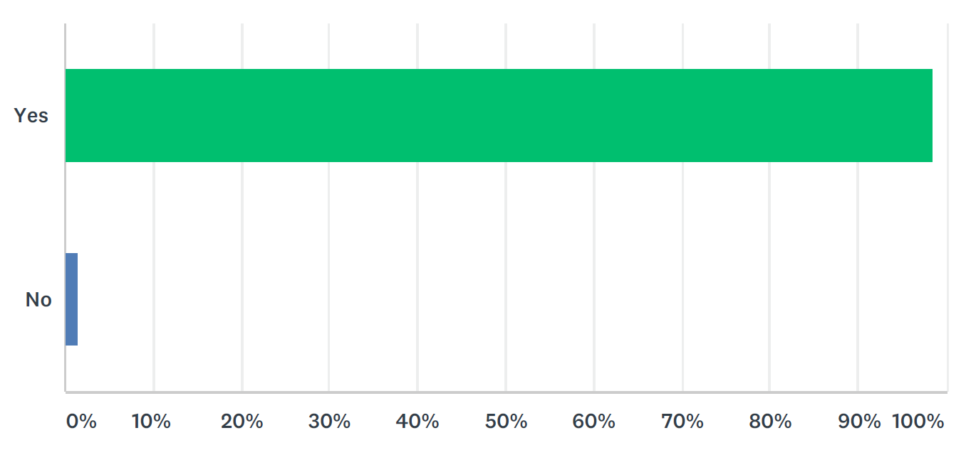

Q2 Do you care for a child/ children (under 18 years of age) that participate in combat sports in the ACT?

Answered: 205 Skipped: 11
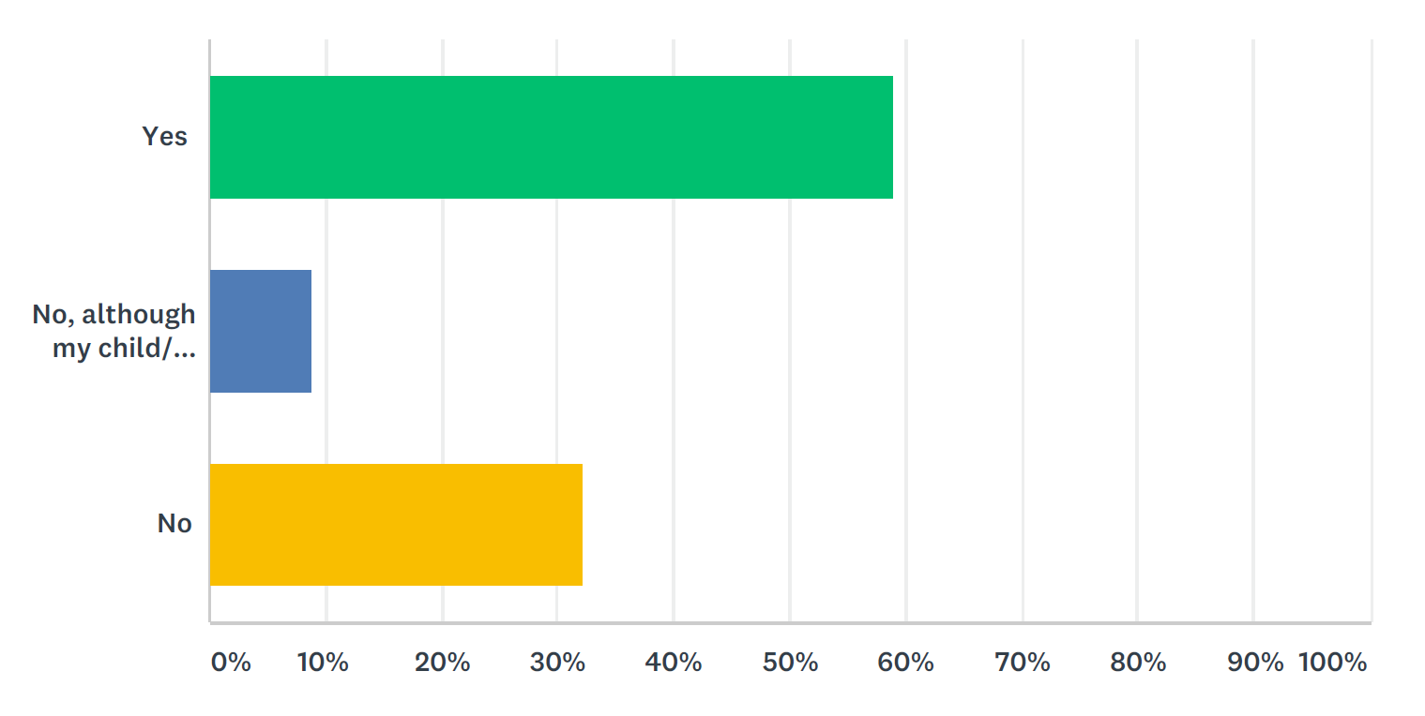

Q3 What combat sport does your child/ children participate in (including past participation)? Select all that apply:

Answered: 134 Skipped: 82

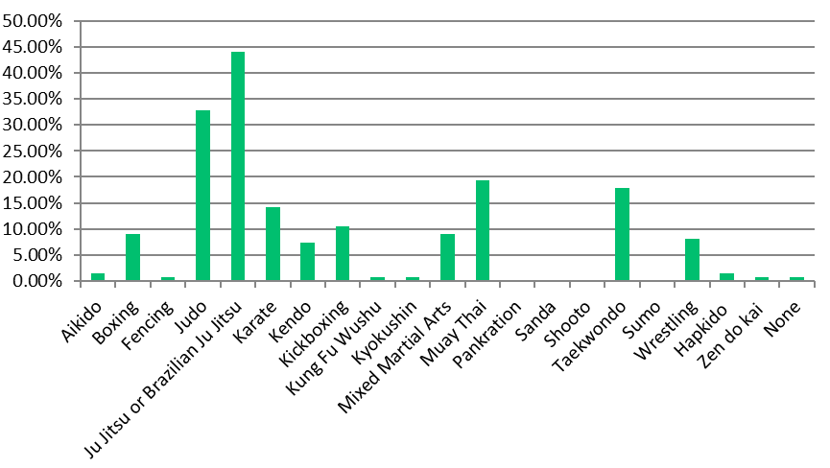

Q4 Of the combat sports you selected above, in what ways do they participate?

Answered: 134 Skipped: 82

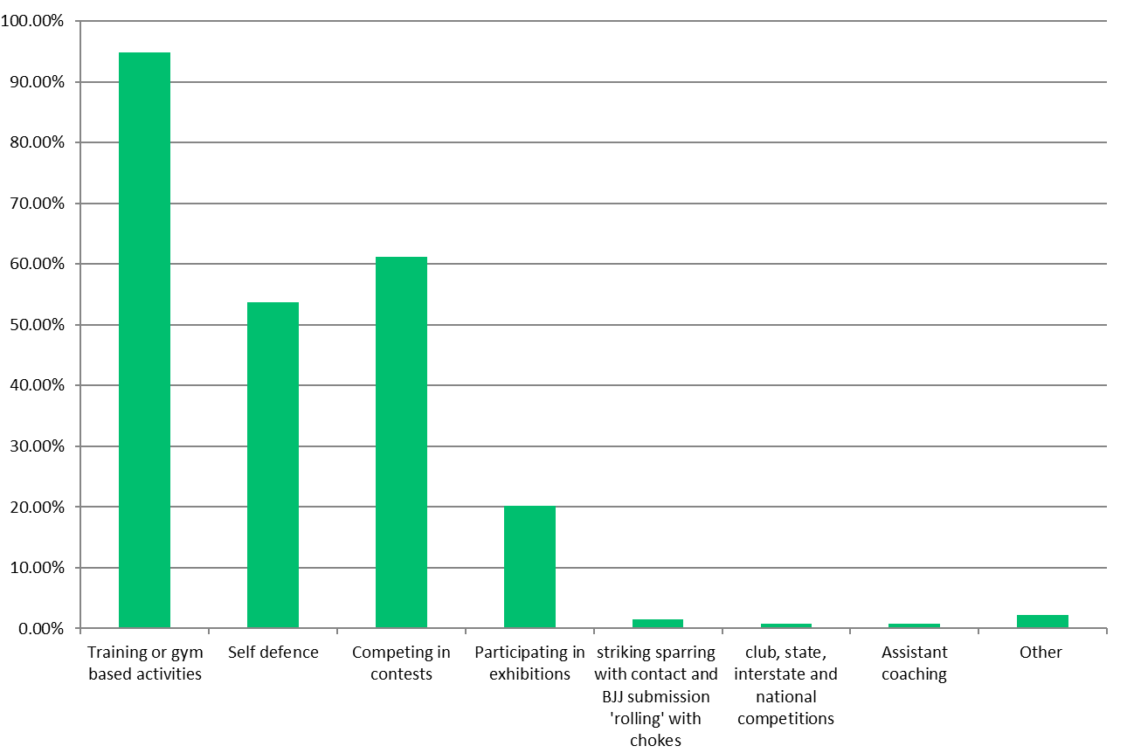

Q5 – 9 Age of survey respondents’ child or children participating in combat sports (including past participation) n=157 children

Answered: 134 Skipped: 82

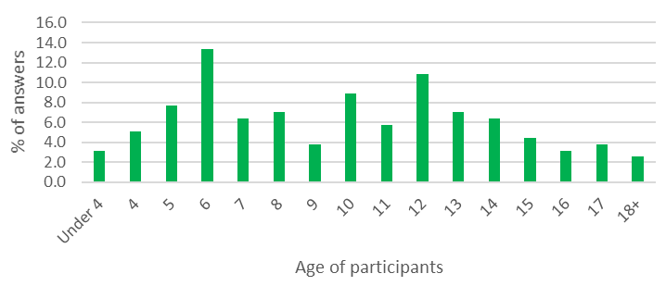

Q5 – 9 Percentage of responses from families with more than one child

56.1% of responses

Q10 What do you consider are the benefits of participating in combat sports? List as many as you like.

Answered: 115 Skipped: 101

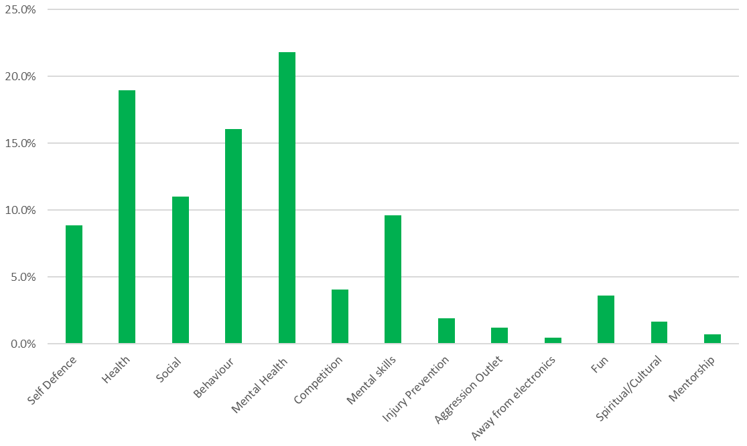

Q11 What do you consider are the risks of participating in combat sports? List as many as you like.

Answered: 112 Skipped: 104

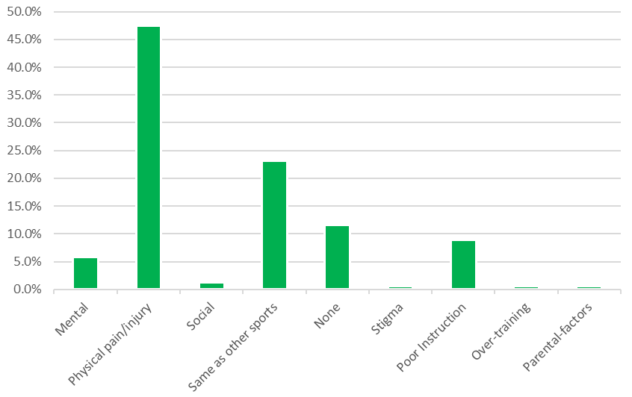

Q12 Are you aware of any instances where a child has suffered an injury as a result of participating in combat sports?

Answered: 115 Skipped: 101

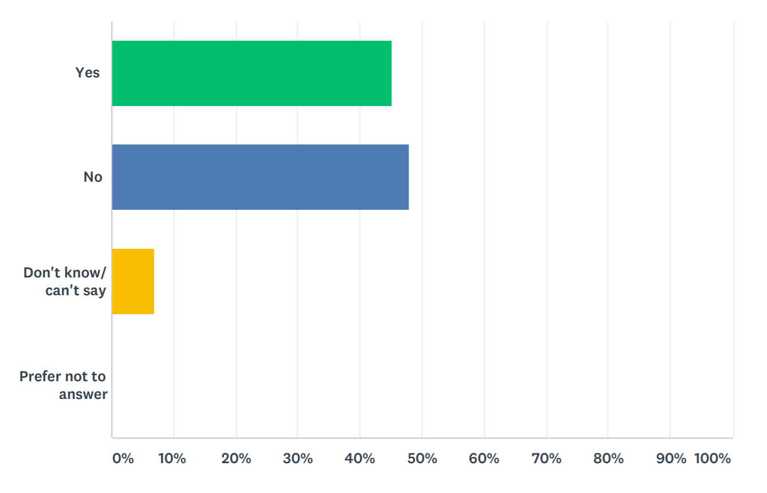

Q13 To the best you can recall, how severe was the injury?

Answered: 52 Skipped: 164

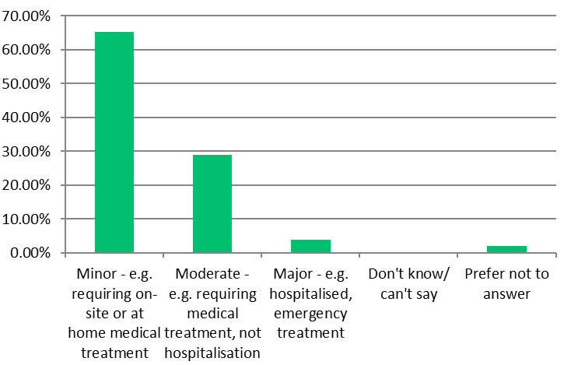

Q14 Do you think there should be special measures in place for children participating in combat sports? For example, use of protective equipment, restrictions on techniques etc.

Answered: 51 Skipped: 165

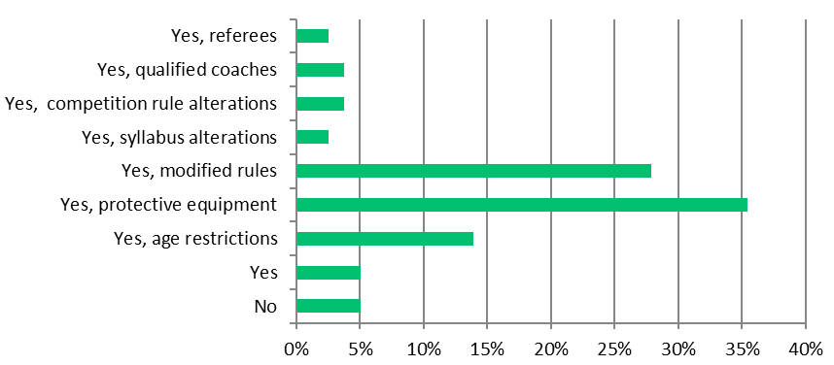

Q15 To what extent do you agree or disagree with the following statement: Children should be prohibited from using combat sporting techniques that involve contact with the head, neck, spine or groin

Answered: 110 Skipped: 106

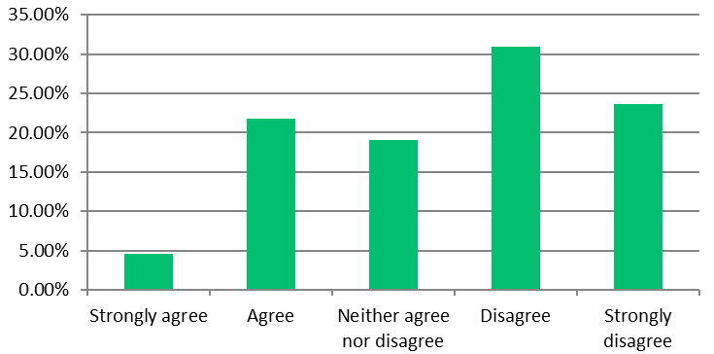

Q16 To what extent do you agree or disagree with the following statement: Sporting organisations should be able to set their own minimum age for participation in their style of combat sport

Answered: 110 Skipped: 106

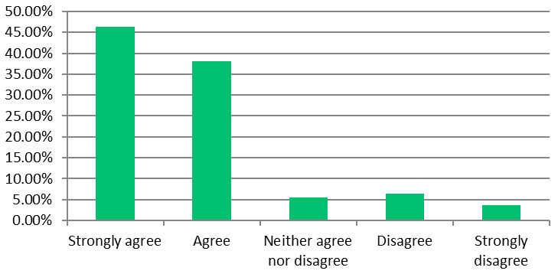

Q17 To what extent do you agree or disagree with the following statement: Sporting organisations should be able to apply for an exemption for their contestants under 14 years of age, to use techniques involving contact with the head, neck, spine or groin

Answered: 110 Skipped: 106

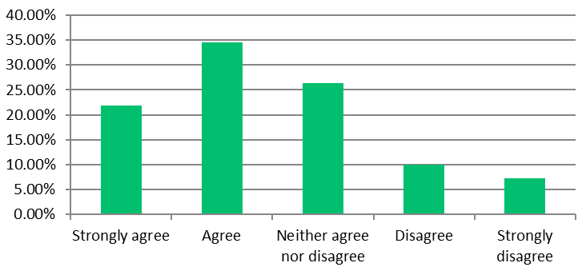

Q18 To what extent do you agree or disagree with the following statement: Individual athletes, under 14 years of age that are considered an elite or promising athlete, should be able to apply for and exemption so they can use prohibited techniques involving contact with the head, neck, spine or groin.

Answered: 110 Skipped: 106

Q19 If restrictions are put in place during contests to prohibit children under 14 years of age to use techniques that make contact with the head, neck, spine or groin, how would this affect your child’s/ children’s participation in their combat sport in the future?

Answered: 106 Skipped: 110

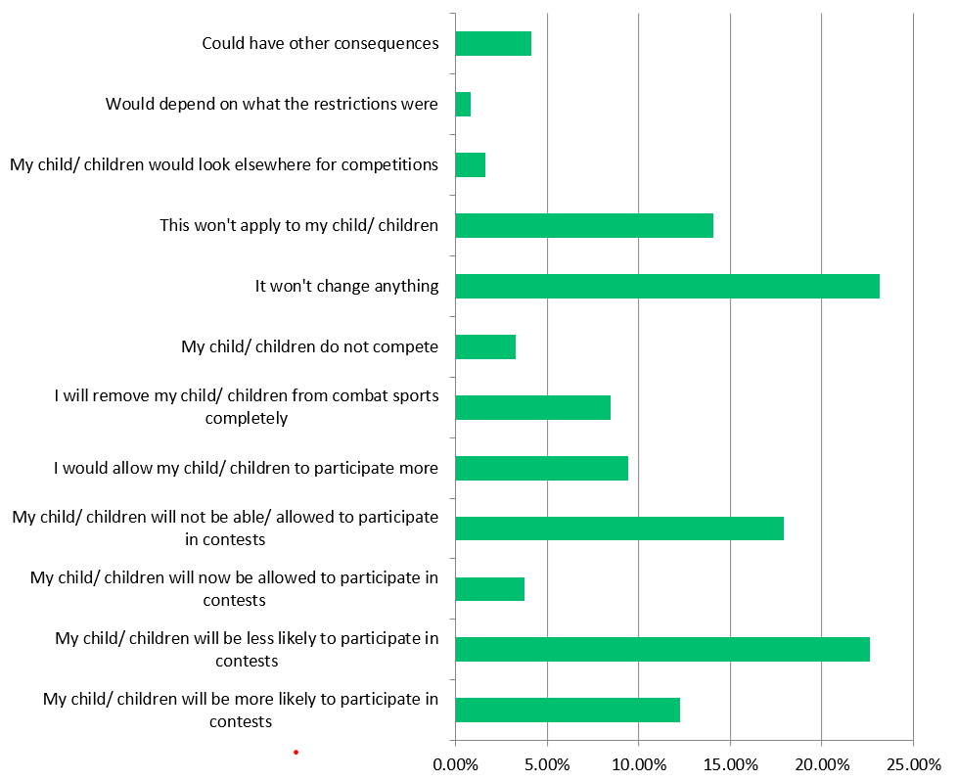

Q20 To what extent do you agree or disagree that the safety of children under 14 years of age would improve if techniques that make contact with the head, neck spine or groin are restricted during contests?
The answers offered for this question were entered incorrectly, resulting in a repeated option to agree or strongly agree rather than providing the option to disagree or strongly disagree. This was corrected on 27 June 2019 at 9pm. However, due to the integrity of these answers being compromised, they have not been included in this report.

Q21 Are there any other measures that could be taken that would increase safety for children participating in combat sports? Please write your answer below.

Answered: 79 Skipped: 137

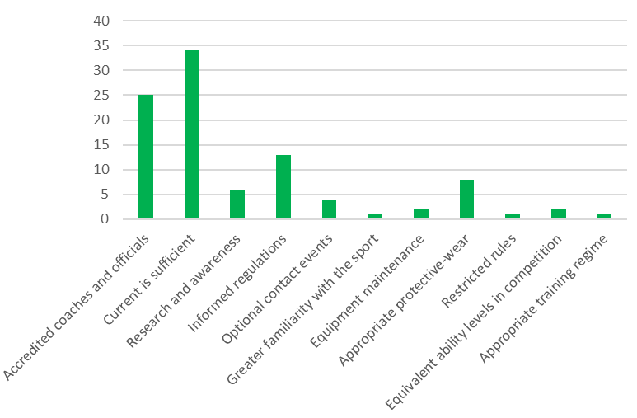

Q22 What suburb do you live in?

Answered: 104 Skipped: 112

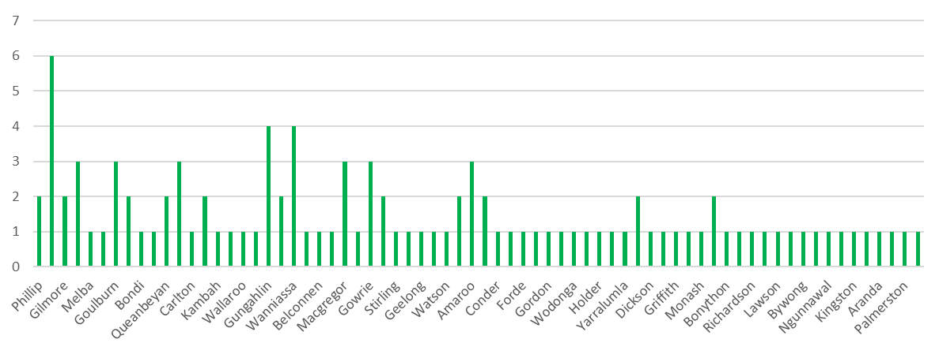

Q23 What is your age range?

Answered: 105 Skipped: 111

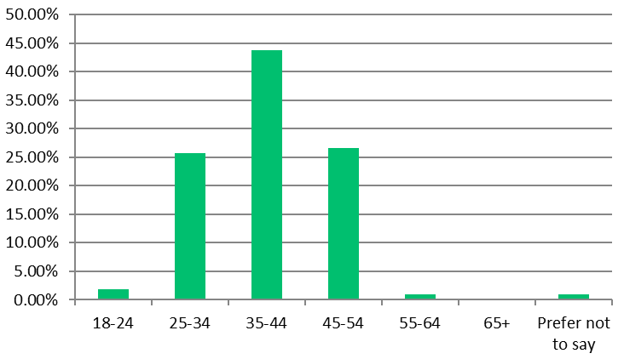

Q24 What is your gender?

Answered: 105 Skipped: 111

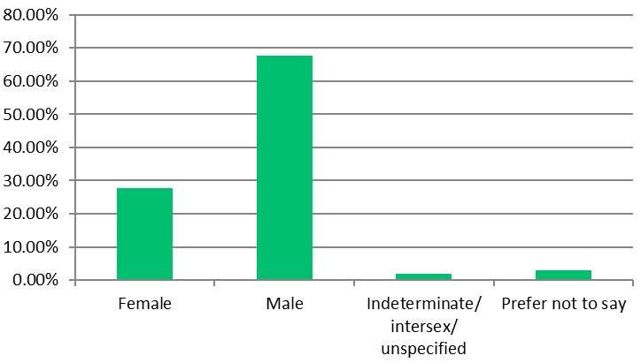

Q25 Would you like to provide more feedback or schedule a meeting with us?

Answered: 91 Skipped: 125

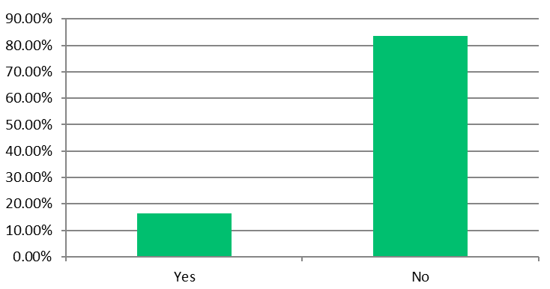

Q26 I am interested in attending a parent/ carer session or one on one meeting *Your personal details will not be linked to your response *

Answered: 12 Skipped: 204
Personal information relating to this response has not been included in this report due to privacy concerns.

Q27 If you would like to be notified of the findings of the consultation, please include your email address below:* Your personal details will not be linked to your response *

Answered: 30 Skipped: 186
Personal information relating to this response has not been included in this report due to privacy concerns.

